NAAN MUDHALVAN

SALESFORCE PROJECT REPORT

COLLEGE: SCAD COLLEGE OF ENGINEERING & TECHNOLOGY

BATCH – 12

|  |  |  |
| --- | --- | --- |
| **NAME** | **NM ID** | **REG NO** |
| AADHAM .P | A0924504D422490B0394A6309D8C4382 | 952820114301 |
| MOHAMED KHAN .T.N | ECS164088B72FEC817D4B148F99557FC | 952820114335 |
| AHAMMED KANSHA .S.H.M | AC2CDS231E87058AEB74BF0C3F256E1F | 952820114306 |
| KHANSA DURAI .K | 46AA95A595AA5CDBE48454A41EE542BA | 952820114324 |

Step 1: Create a Salesforce Account

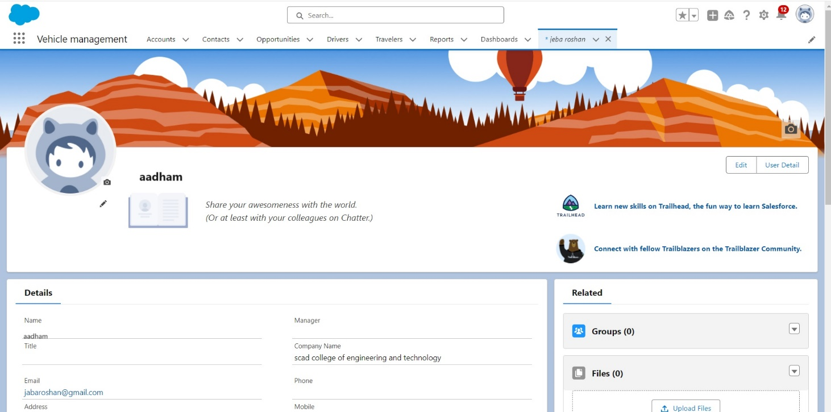

Step 2 : Create the Objects( DRIVER,TRAVELER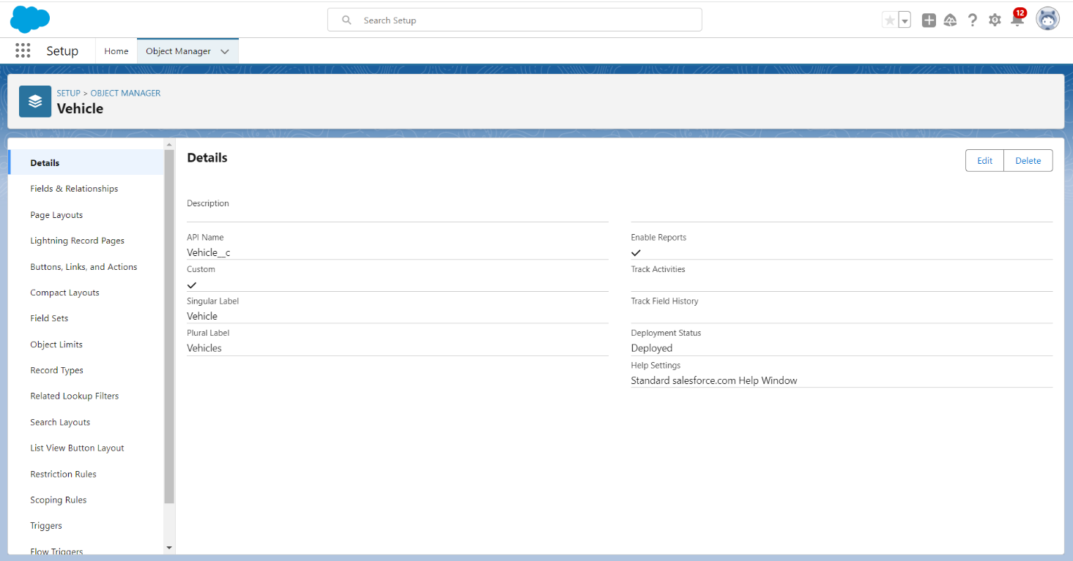)

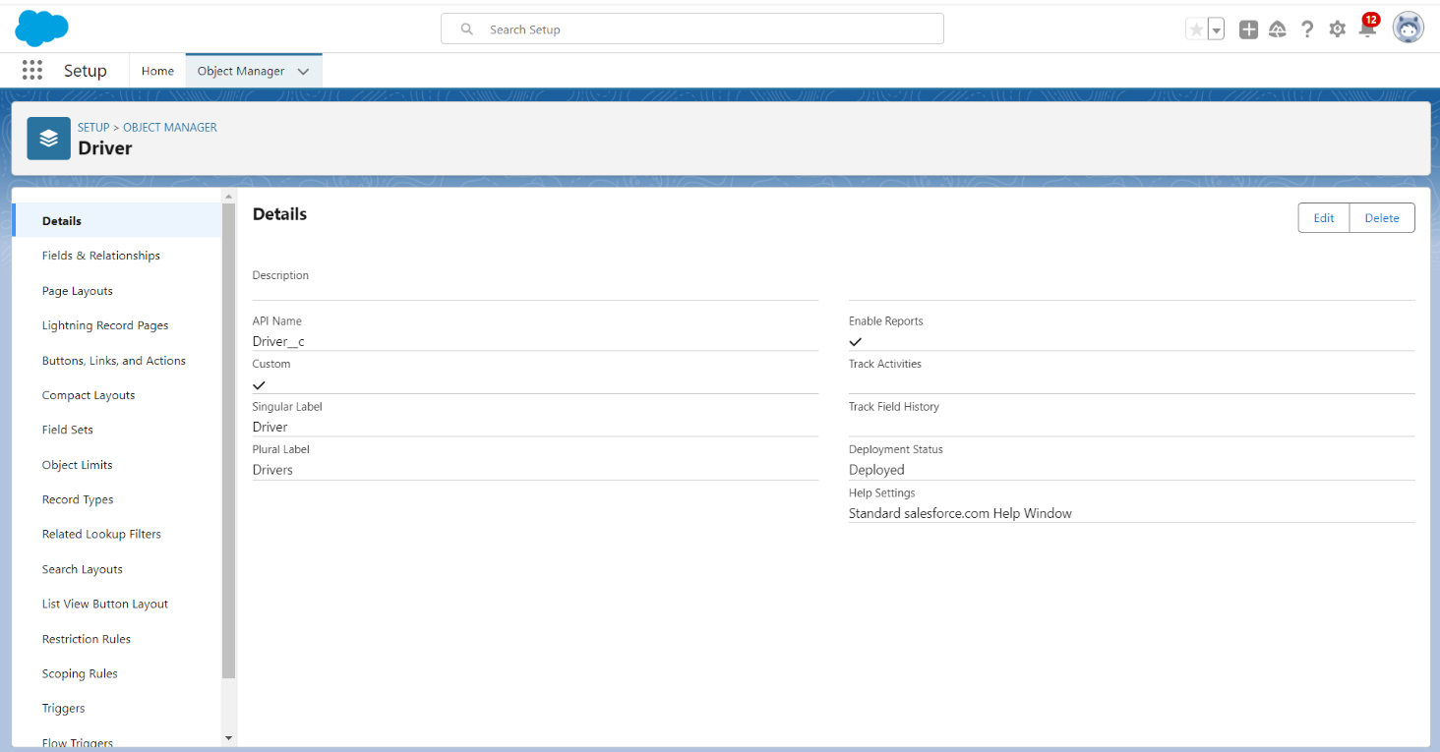

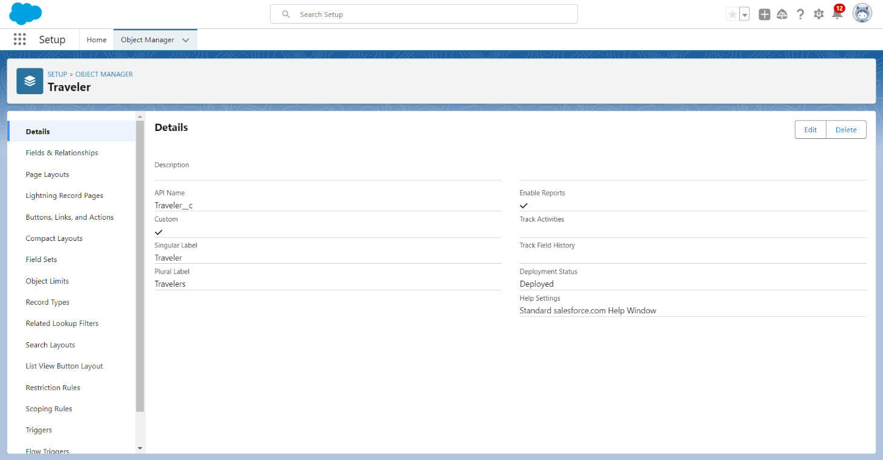

Step 3 : CREATE AFIELD RELATIONSHIP (DRIVER,TRAVELER)

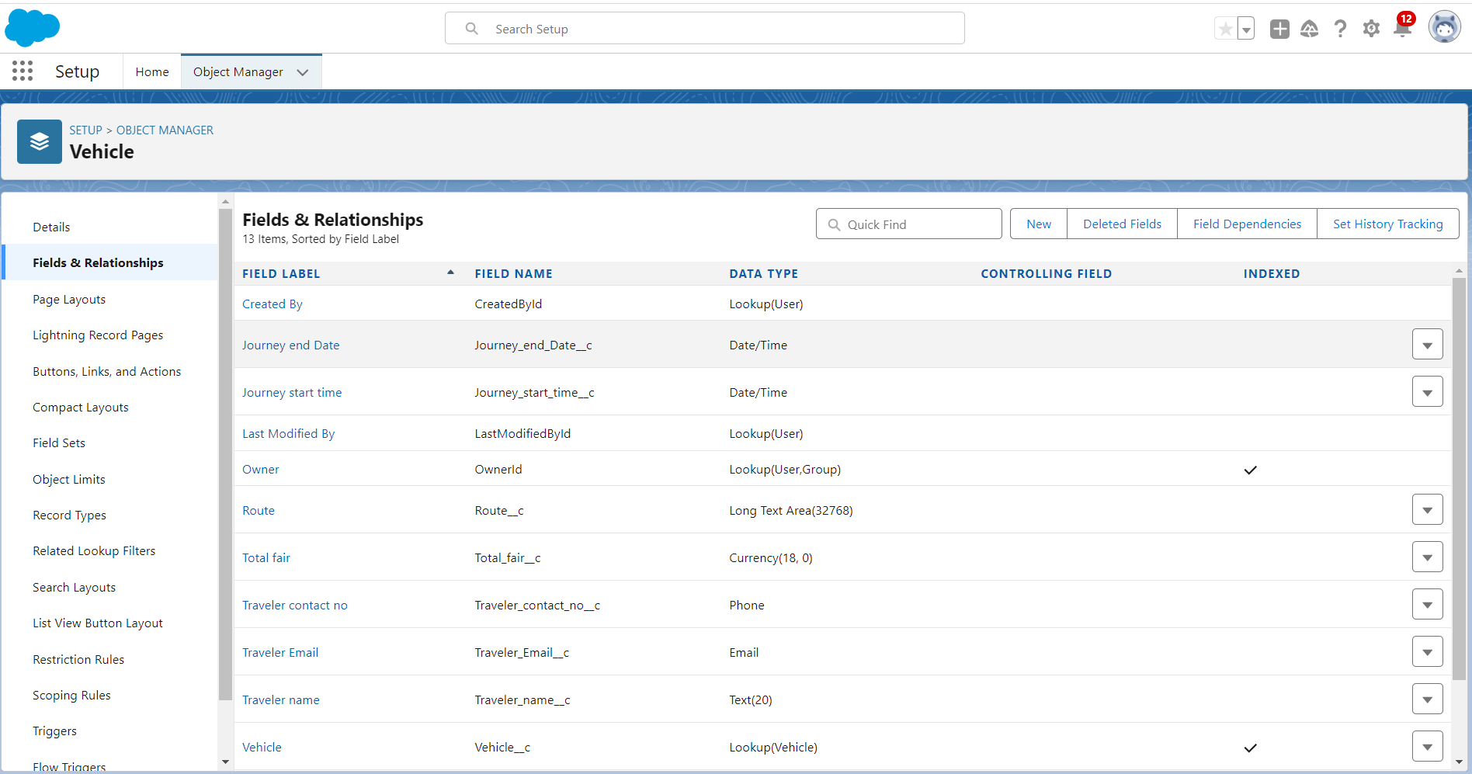

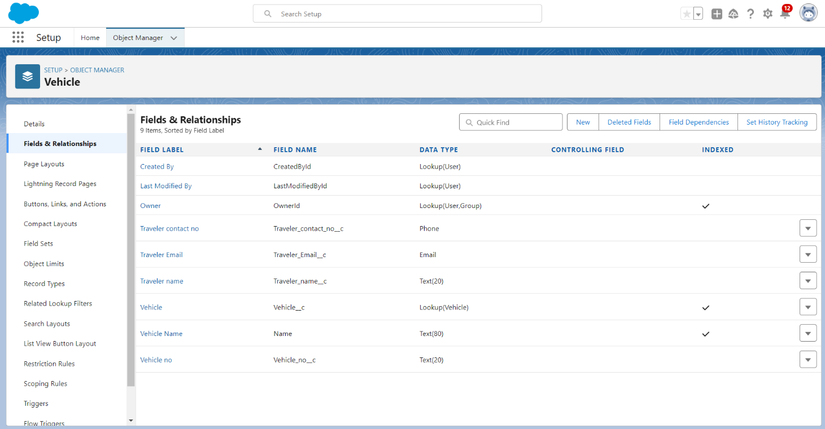

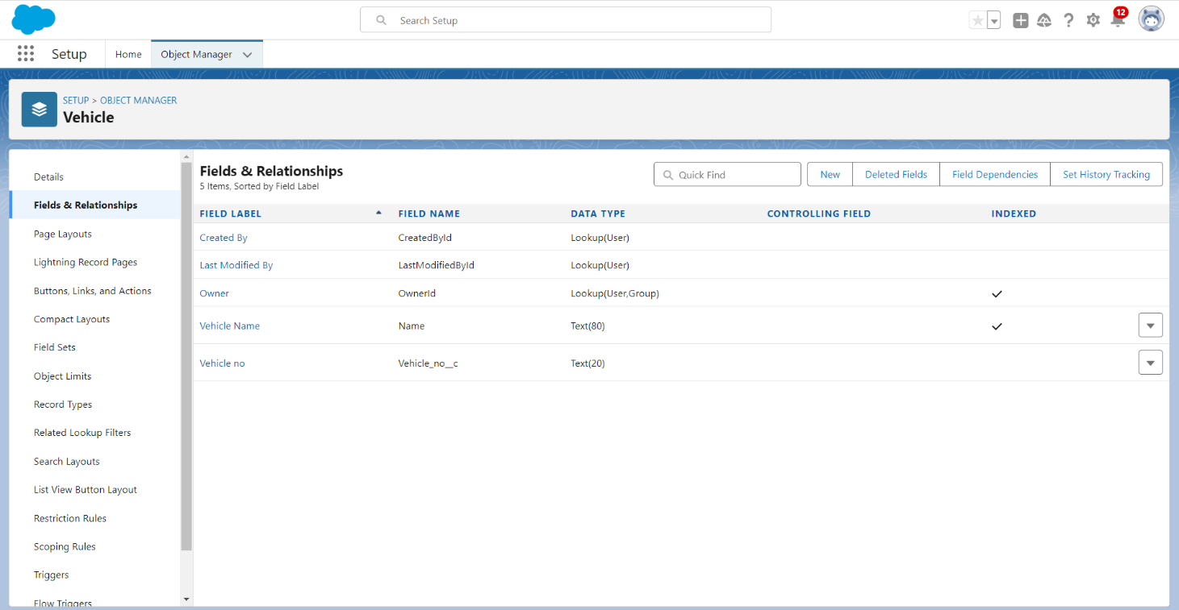

1`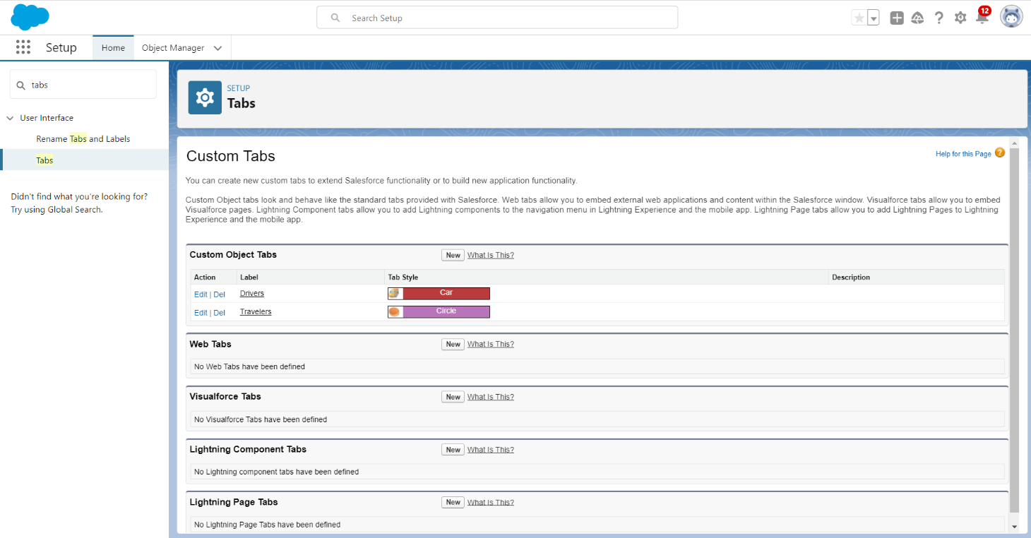

Step 5 : Create a Lightning App

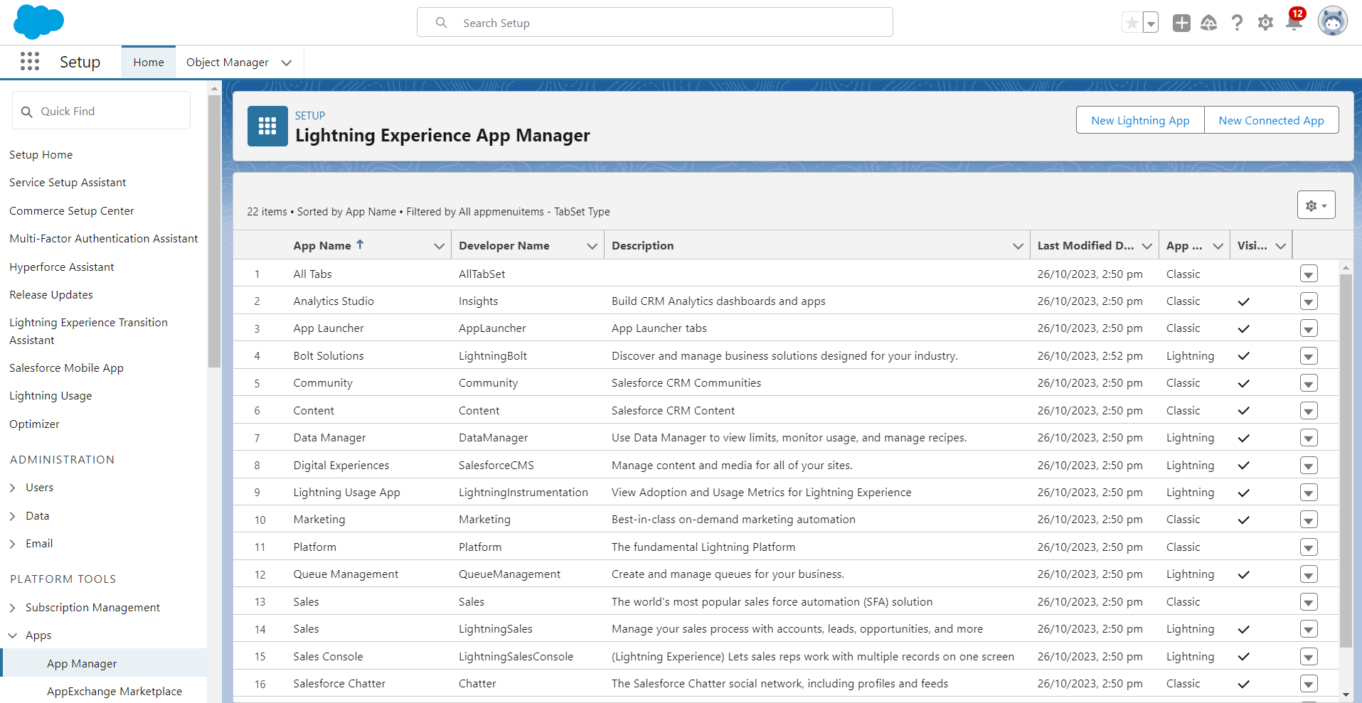

Step 6 : Create the PROFILE

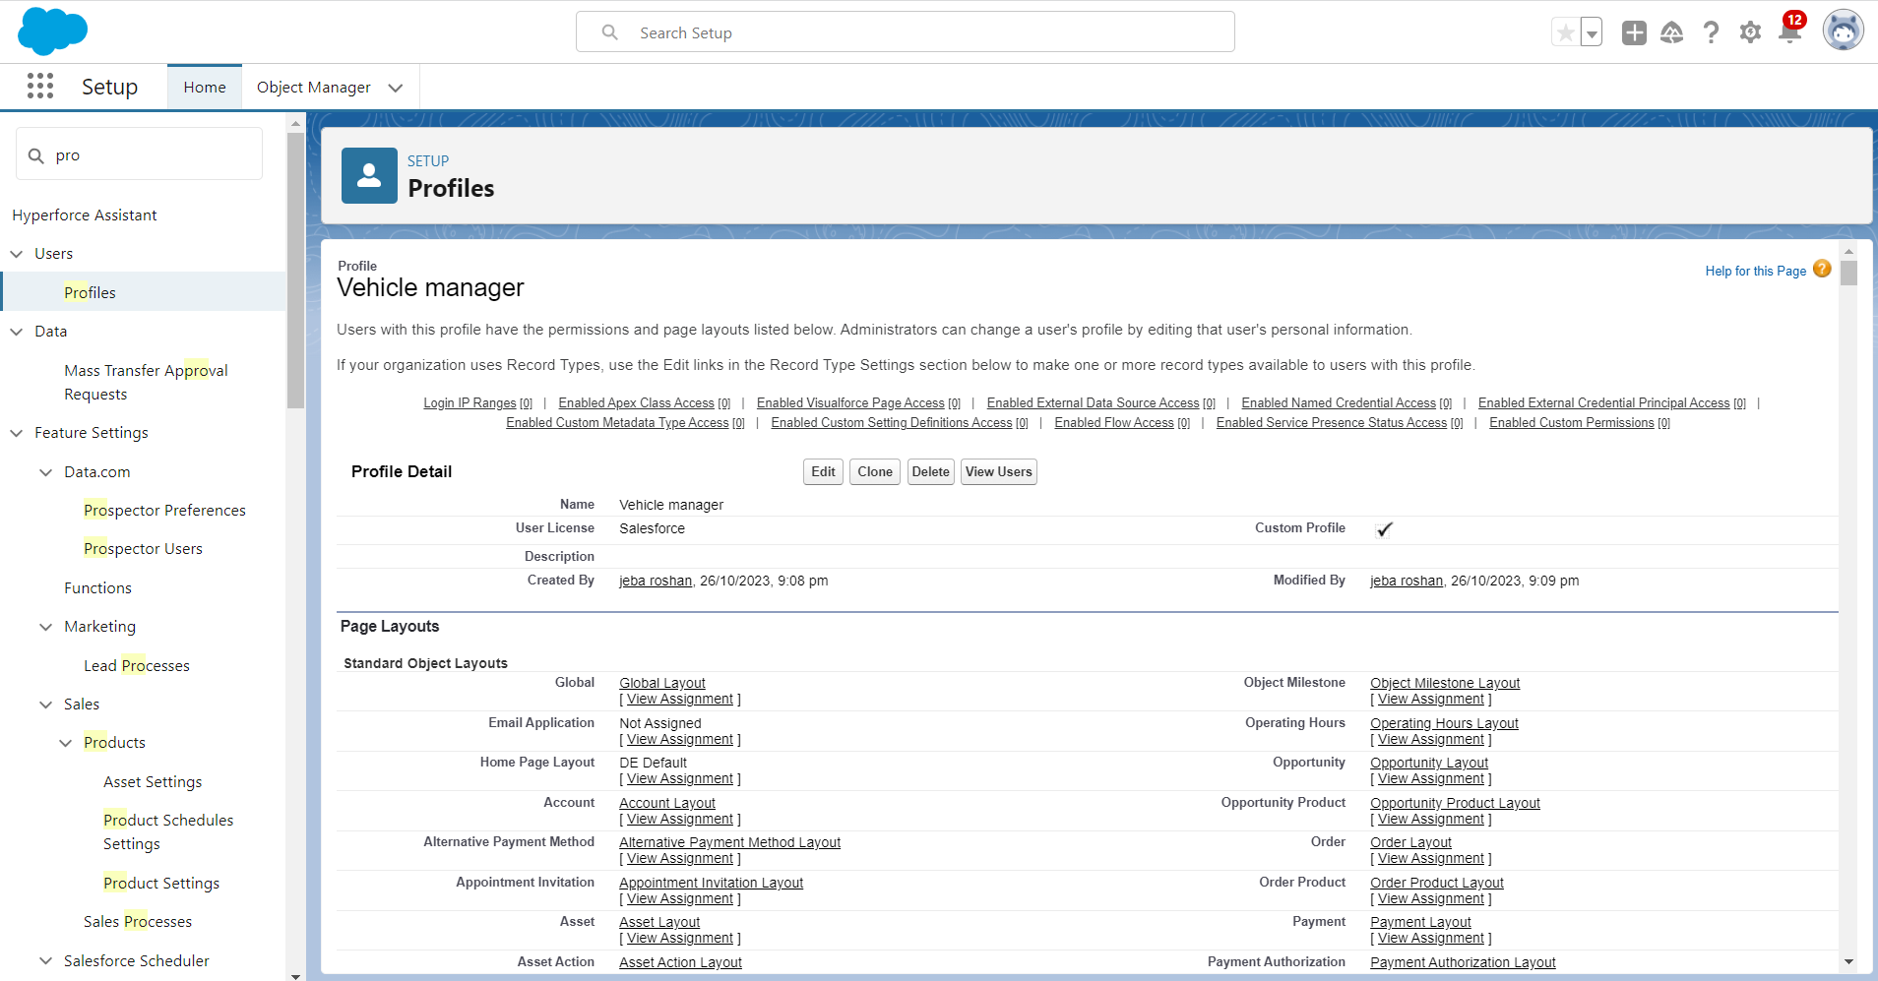

Step 7 : Create the User

Step 8 : Create the PAGE LAYOUT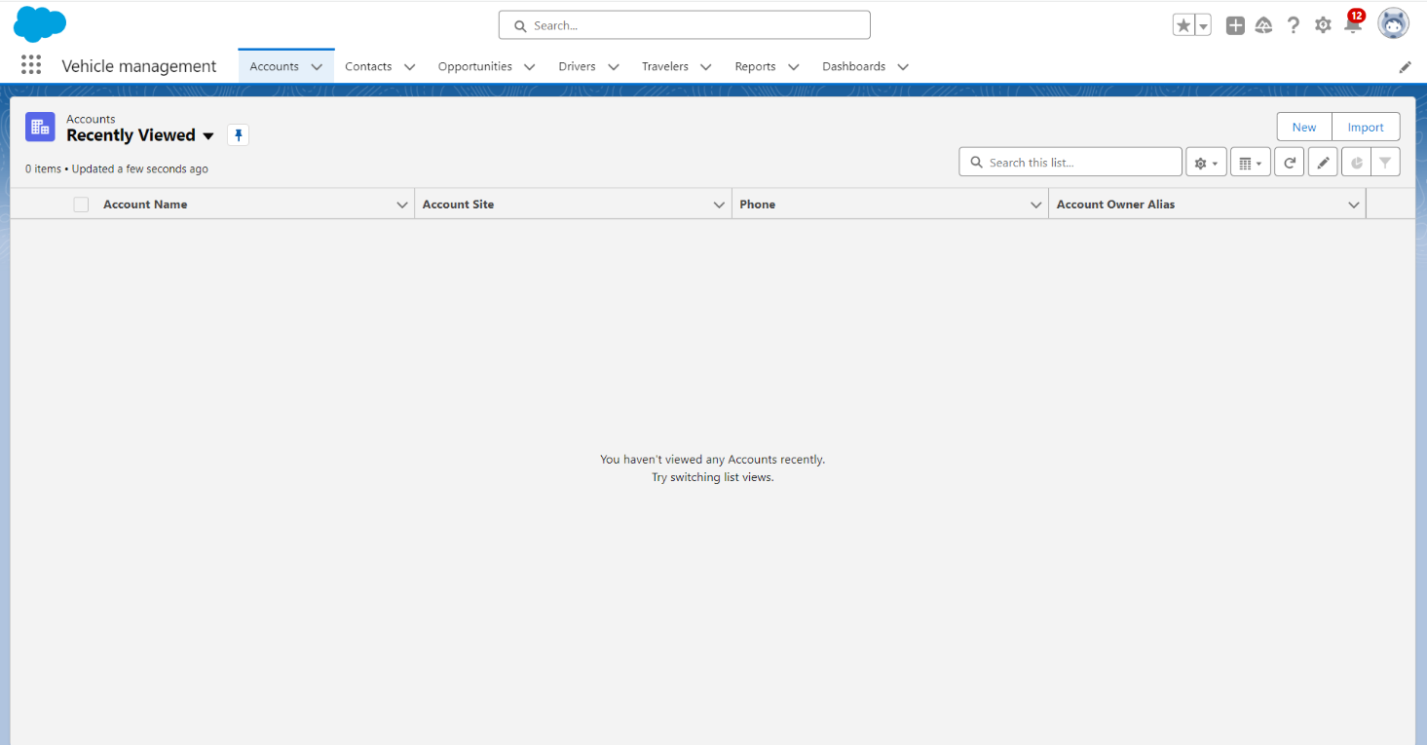

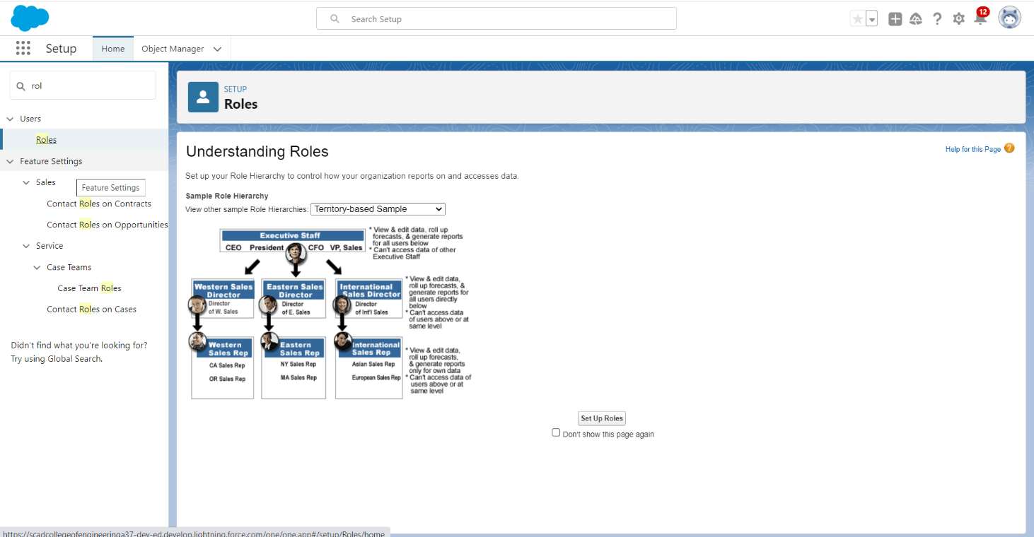

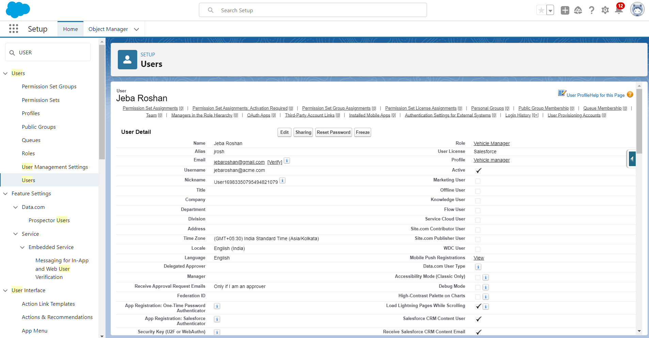

Step 10 : Create user adoption

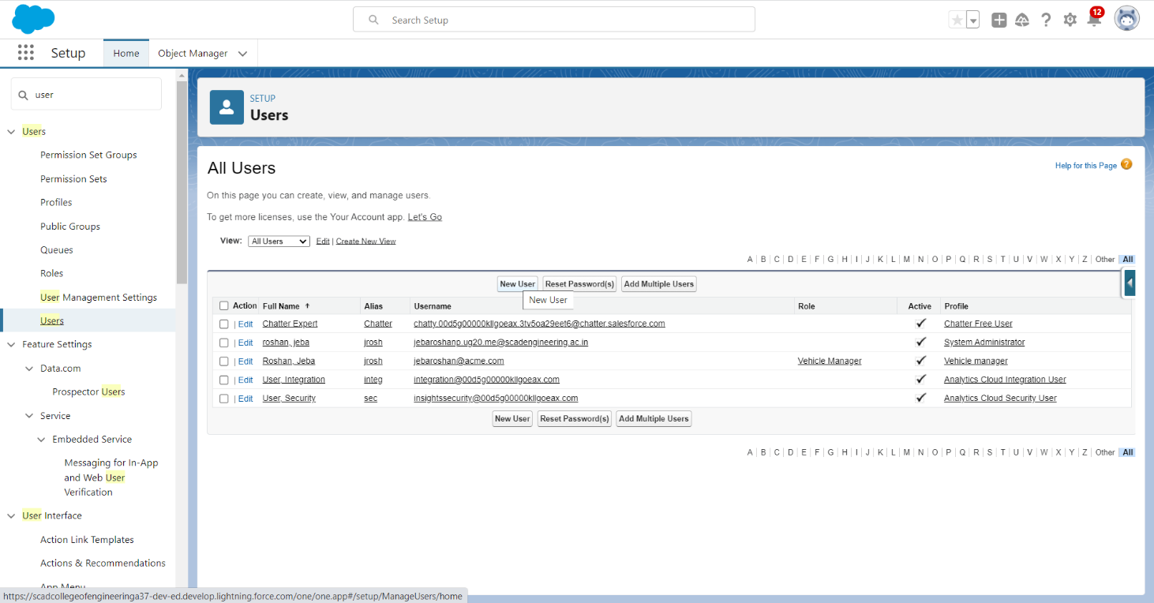

Step 11 : REPORTS AND DASHBOARDS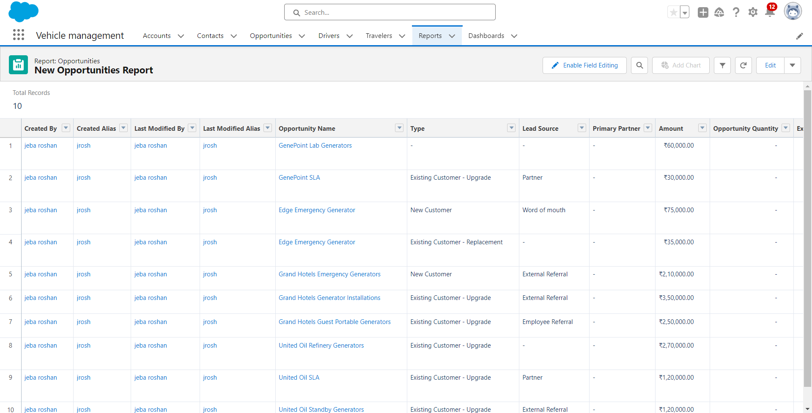

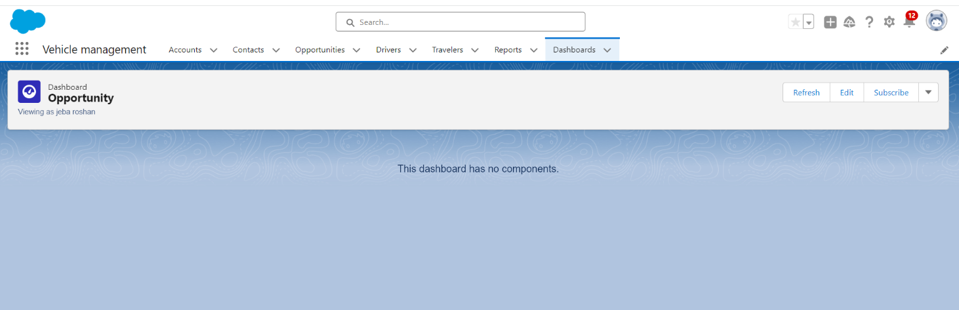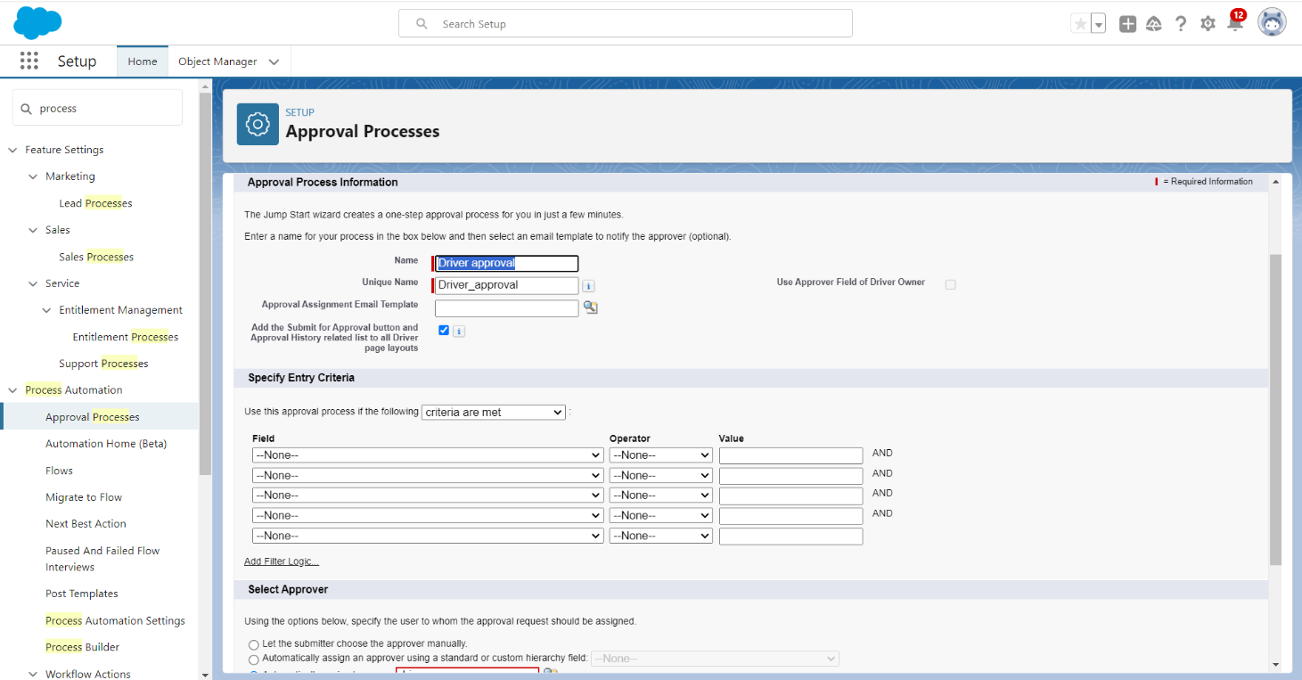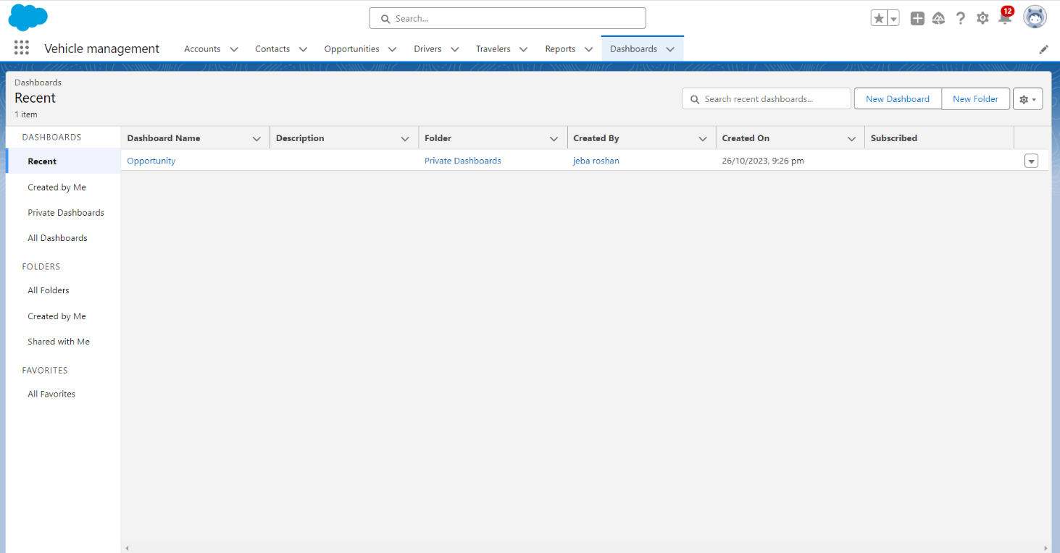

Step 12 : Create view report and dashboard



Step 13 : Create A flow

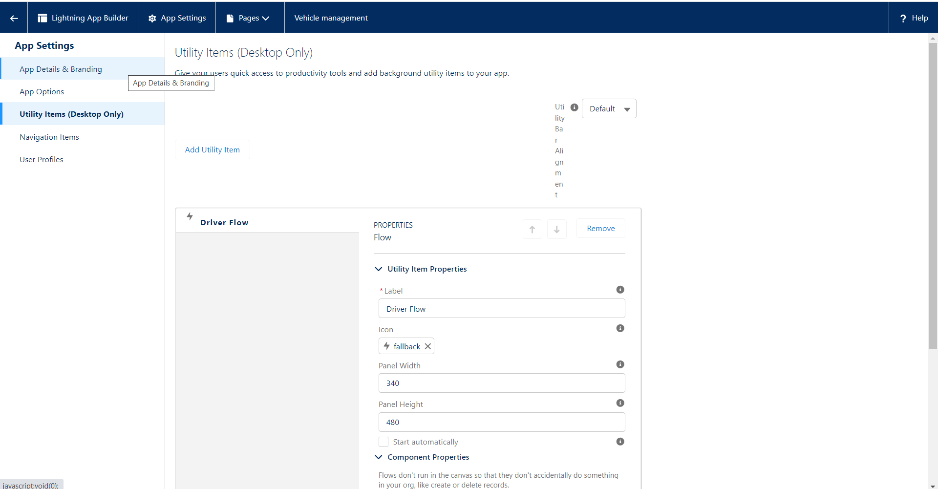

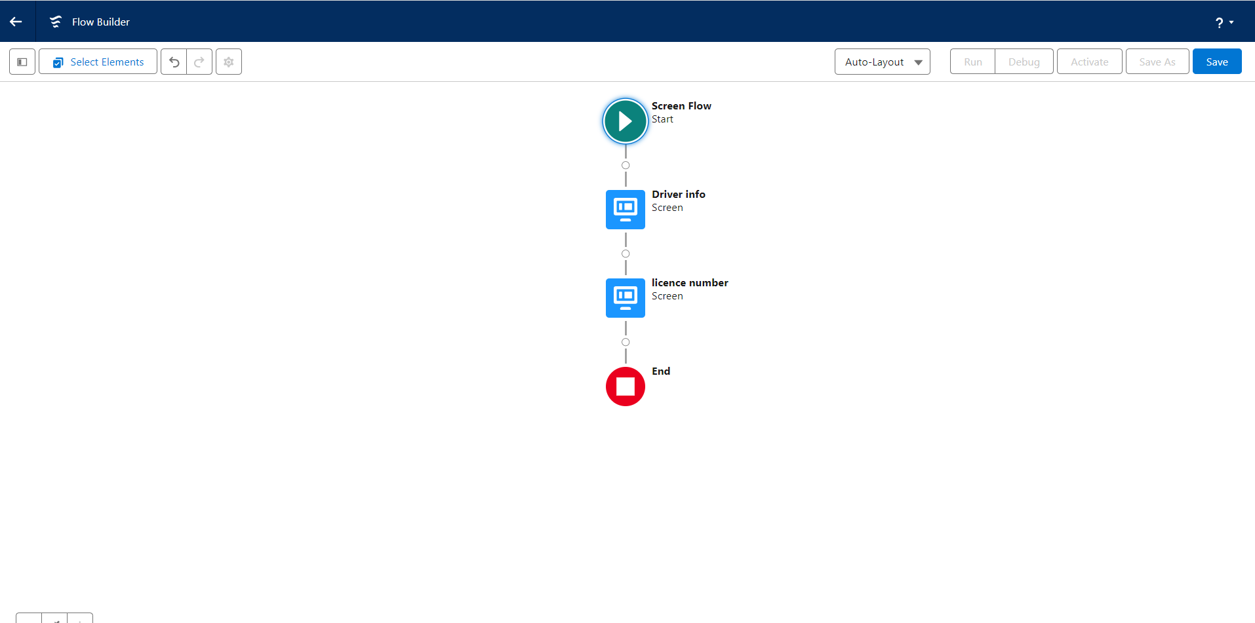

Step 14 : Create App Page

